**SHOPNEST DETAILED REPORT:**

**Acknowledge:** Before going into the report, I have checked and rectified the data thoroughly, where I’ve filtered/removed Null values and unwanted data from the datasets by doing data cleaning action on each dataset table given in the resource and added new column to achieve expected output.

**REPORT:**

**1)** Identify the rating distribution in the Shop Nest dataset, showcasing ratings categorized as Excellent, Very Good, Good, Bad, and Very Bad, along with corresponding orders.

**Visualisation**

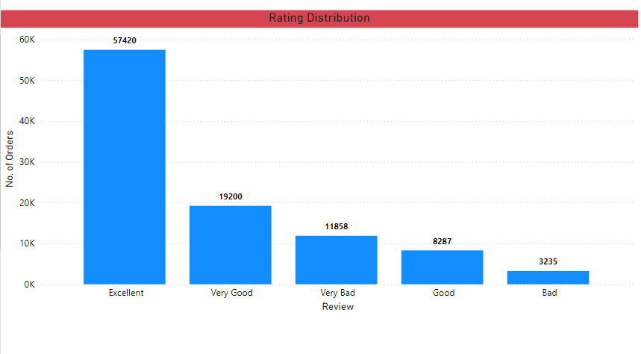

**Explanation:**

I have added a conditional column to the given table, Orders_review_dataset by add column tab where the “IF” condition is applied to specify if review score is 5 it will reflect as “Excellent”, for 4 it will reflect as “Very Good”, for 3 it will reflect as “Good”, for 2 it will reflect as “Bad” and 1 it will reflect as “Very Bad” in review column.

**2)** What are the top 10 and bottom 18 most popular product categories in the ShopNest dataset? Please list them based on the number of orders.

**Visualisation**

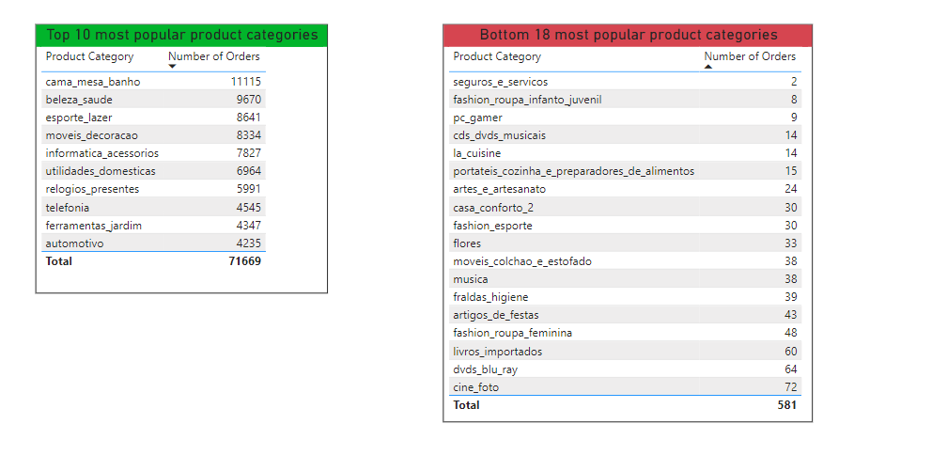

**Explanation:**

I have used table visual and selected order id column from orders_items_dataset and product category name from products_dataset. From these table I’ve created top 10 popular product categories with sorting to descending and Bottom 18 product categories with sorting to ascending. From this visualisation we can understand that cama_mesa_banho has high number of orders and seguros_e_servicos has least number of orders.

**3)** List the total number of active sellers by yearly and monthly.

**Visualisation**

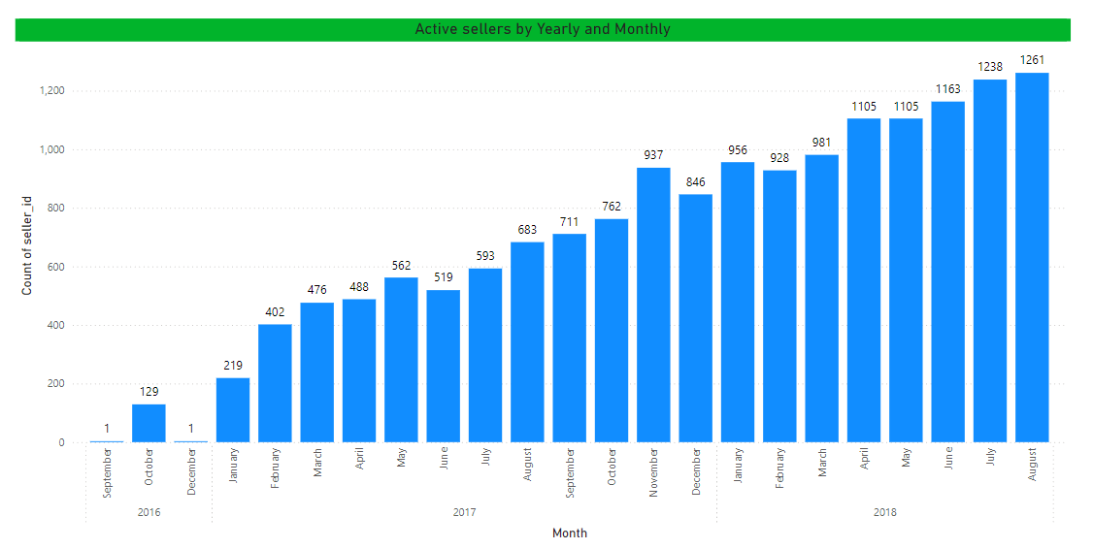

**Explanation:**

I have used stacked column chart to visualise the active sellers by yearly and monthly. Here I came across for inactive sellers by observed that in the order purchased timestamp from orders dataset table the sellers having no timestamp which indicating that the seller is inactive as order has placed but the shipping was not placed. So, from filtering the data in report view we can list the active seller for yearly and monthly as shown in the above visualisation. Here we can observe that the active sellers are gradually increasing year by year which is significantly a positive sign.

**4)** Which payment methods are most commonly used by ShopNest customers.

**Visualisation**

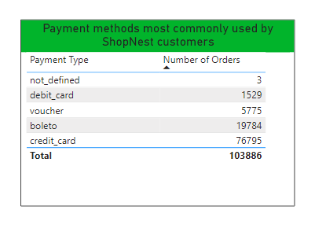

**Explanation:**

I have selected order id and payment type columns from order payments dataset, taken payment type column in Y axis and Order id column in X axis. As the count of order id is selected, so from the dashboard it is clearly witness that highest number of orders are taken by using credit card. Therefore, Credit card is the most commonly used payment method.

**5)** Determine the monthly payments made by customers using credit cards.

**Visualisation**

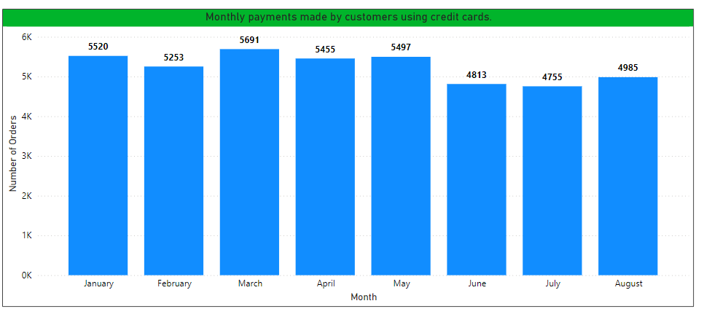

**Explanation:**

The stacked bar chart visualisation shows the visuals on the basis of payment done by using Credit card on monthly wise. For this I have taken the data from orders dataset and Order payments dataset table. From the visualisation, it has observed that payment made by credit card was highest in March and followed by January and the month in which the usage recorded lowest payment using credit card is July. Overly, we can observe that the average monthly payments using by credit card is above 5000 units.

**6)** Identify sellers categorized by city, excluding cities starting with the letters S and B.

**Visualisation**

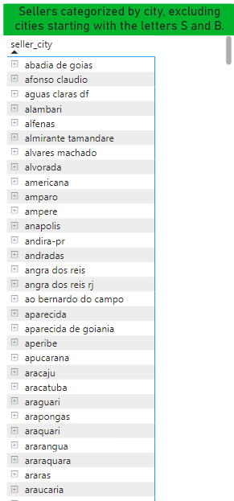

**Explanation:**

I have selected sellers dataset to choose seller_id and seller_city to obtain result on the asked query that is to find the city of sellers excluding the cities which starts with ‘S’ and ‘B’. For this I have filtered the columns in the report view with advanced filter to remove cities which starts with ‘S’ and ‘B’. The above Visual shows the cities of the seller on asked condition.

**7)** Create a dynamic visual that compares the number of delayed orders to the number of orders received earlier for each month. Utilize the drill through the cross-report feature to provide a detailed analysis of late and on-time deliveries.

**Visualisation**

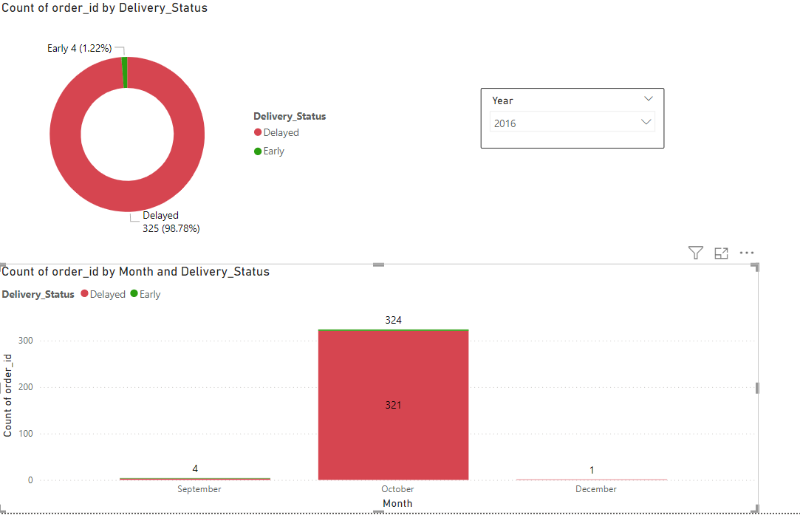

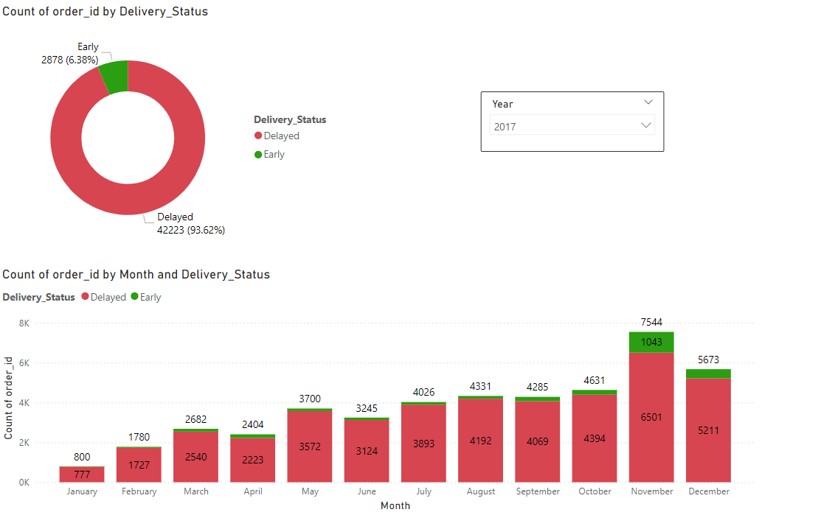

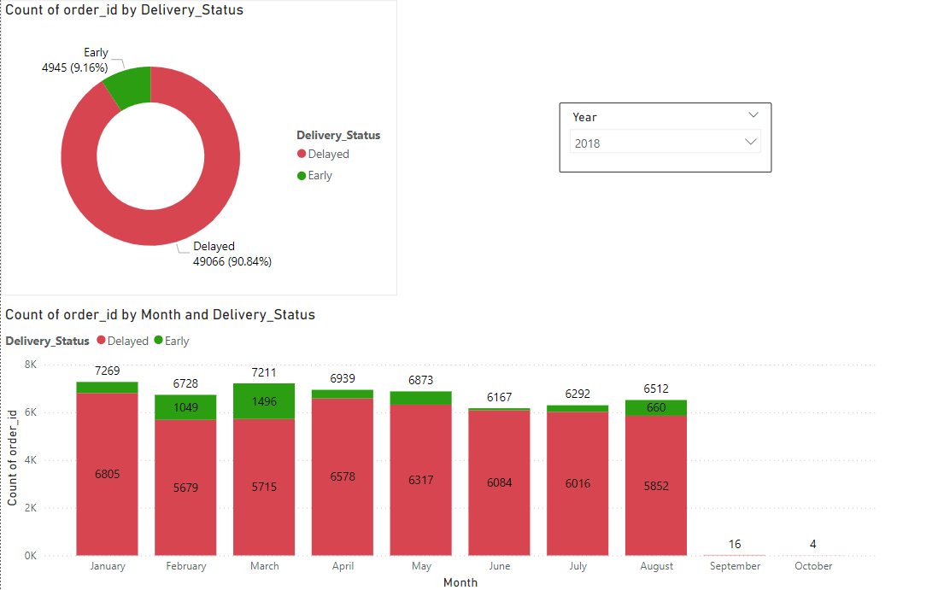

**Explanation:**

To provide a clear visual of delayed and early orders for every month in each year I’ve considered order_id and purchased timestamp columns from Orders dataset table. Here, to understand it more clear on delay and early deliveries, I’ve created new column for delivery status to make drill-down for more understanding. I have used slicer to filter each year reading for more understanding year-year. From the visualisation of each year, we can observe that there are less deliveries are made in the first year with delay deliveries however early deliveries are lower in the score. The rate of deliveries is gradually increased in every year but as shown in the pie chart the maximum deliveries were reached delay to the customer. Here we can also note that the early deliveries are pushing forward year by year, by increasing rate of early delivery and reducing the rate of delivery delay.

For example, if we see the rate of early deliveries in 2016 is 1.22% and in 2018, it is 9.16%. It is gradually improving.